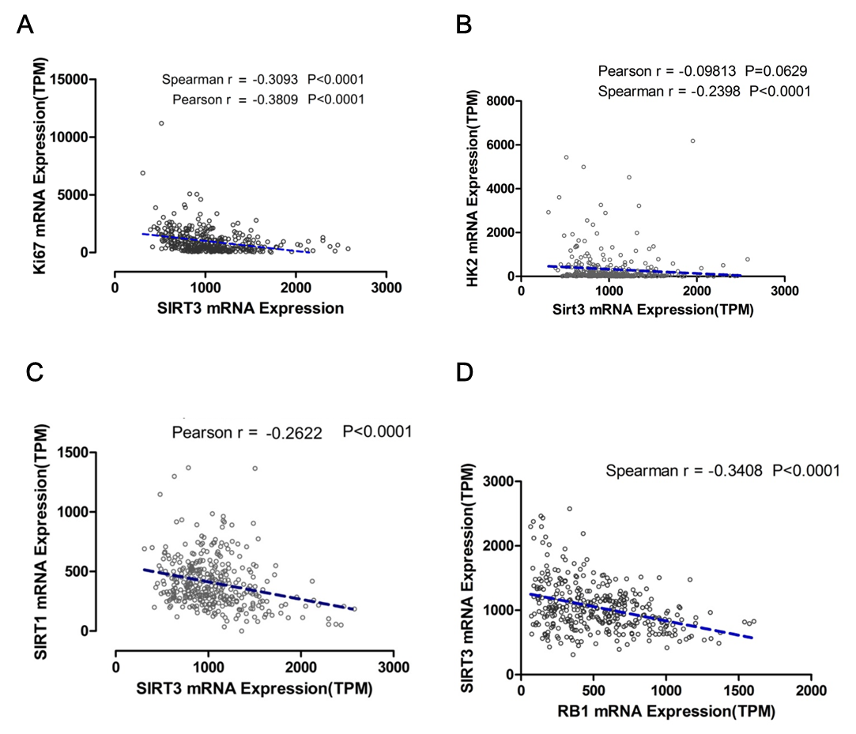

Supplementary Data 1. TCGA data analysis. The indicated mRNA level of the Cancer Genome Atlas (TCGA) Liver Hepatocellular Carcinoma data was obtained from OncoLnc(www.oncolnc.org) TCGA data portal.

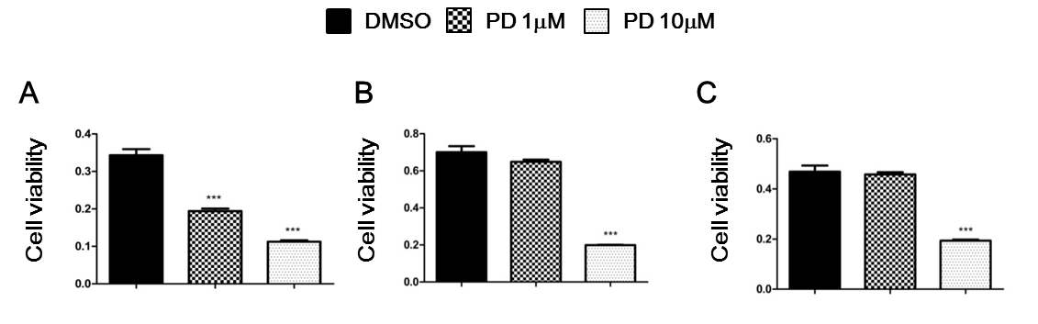

Supplementary Data 2. Cell proliferation after PD032991 treatment in HCC cells. HepG2 cells (A), Huh7 cells (B) and SK-HEP1 cells (C) were treated with DMSO, 1uM PD032991 or 10uM PD032991. After 48h, cell proliferation was measured by WST-1 assay. Data from six technical replicates were analyzed and expressed as the mean ± SD.;***, P < 0.001

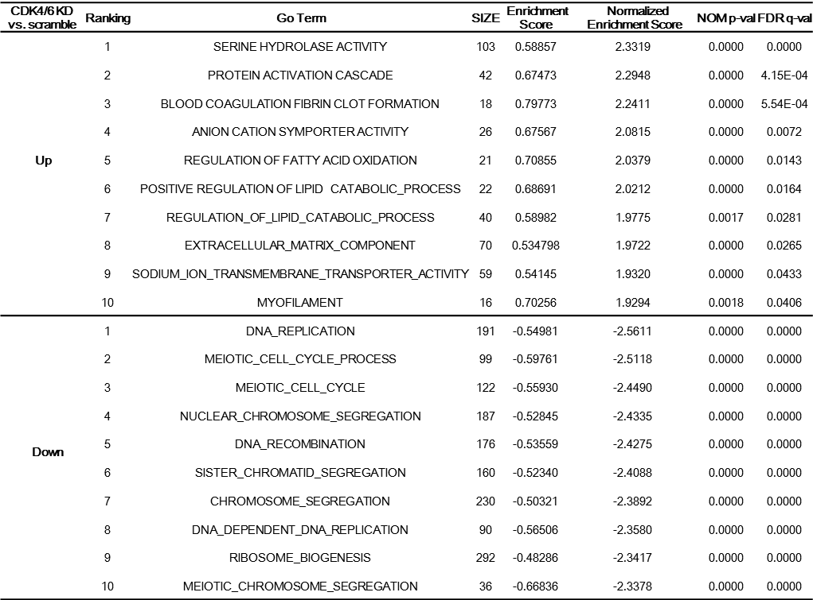

Supplementary Data 3. Gene set enrichment analysis (GSEA)

